ITEC 3200

Database Summery

Khaled Asad

Top Car build is a database for customers that allows them to design their dream car. With this database, the customer can fully customize their car from the interior to the exterior. Once the customers have made their selections, the price of their car will be displayed for the customer to purchase.

The Top Car Build is made up of eight different tables. The tables names are COSTOMER_ID, ONLINE-ORDER_ID, WHEELS_ID, INTERIOR_ID, CUSTOM-BUILD_ID, ENGINE_ID, TIRES_ID, and lastly BODY_ID. Each table has its unique way of interacting with other. A customer will provide his or her information such as first name, last name, phone number, and address. After providing this information, the customer will be given a unique identification number. Then the customer will be prompted with multiple options to build his or her dream car. The price will be automatically updated each time a customer selects a build for the dream car. A customer is freely allowed to customize the car.

There are many options to select from, for example for the interior the options are: color, type of fabric, heated or cooled seats, navigation, and even sound system. For the engine, a variety of options are: engine size, number of cylinders, driving style, fuel capacity, fuel type, and lastly transmission. When selecting tires, a customer can choose the size of the tires, brand, winter tires if needed, and even racing tires. As for wheels, the customer can select options for the size, color, brand, and type of metal for the wheels. And lastly for the car body a customer can choose a spoiler, the height of the car, exterior color, hood material, door color of paint, roof material, and the lighting off the car. After the customer’s selections are made, the price is displayed and he or she can buy the car from Top Car Build.

The purpose of the Top Car Build database is for the customer to navigate, and choose freely as their hearts desire. Not only that but for the database its self for the easy maneuverability and efficiency. Top Car Build has very minimal redundancy making it a great database to have.

ER-Diagram of Top Car Build

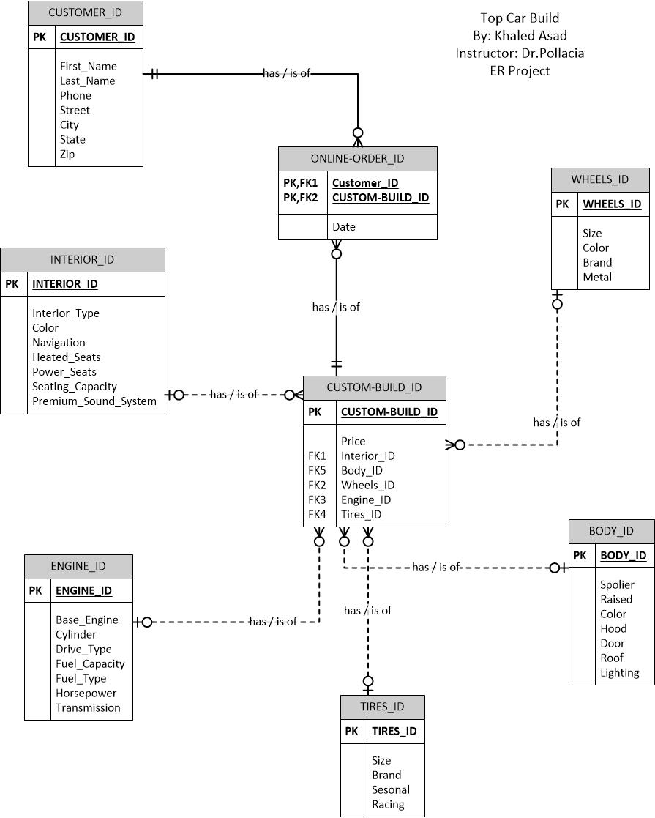

SCHEMA

**CUSTOMER_ID** (Customer_ID, First_Name, Last_Name, Street, City, State, Zip, Phone)

**ONLINE-ORDER_ID** (Date, Customer_ID, Customer-Build_ID)

FK Customer_ID 🡪 CUSTOMER_ID

FK Custom-Build_ID 🡪 CUSTOM-BUILD_ID

**CUSTOM-BUILD_ID** (Custom-Build_ID, Price, Interior_ID, Body_ID, Wheels_ID, Engine_ID, Tires_ID)

FK Interior_ID 🡪 INTERIOR_ID

FK Body_ID 🡪 BODY_ID

FK Wheels_ID 🡪 WHEELS_ID

FK Engine_ID 🡪 ENGINE_ID

FK Tires_ID 🡪 TIRES_ID

**INTERIOR_ID** (Interior_ID, Color, Navigation, Heated_Seats, Power_Seats, Seating_Capacity, Premium_Sound_System)

**ENGINE_ID**(Engine ID, Base_Engine, Cylinder, Drive_Type, Fuel_Capacity, Fuel_Type, Horsepower, Transmision)

**TIRES_ID**(Tires ID, Size, Brand, Seasonal, Racing)

**BODY_ID**(Body ID, Spoiler, Raised, Color, Hood, Door ,Roof, Lighting)

**WHEELS_ID**(WHEELS ID, Size, Color, Brand, Metal)